Title (Times New Roman 13 Bold)
First Author^{1*}; Second Author¹; Third Author² (Times New Roman 12)
¹ Department of …..., University of …, city name, Iran (Times New Roman 11)
² Department of ……., University of …, city name, Iram (Times New Roman 11)
Email: corresponding.author@iau.ac.ir (Times New Roman 10)
Abstract
English abstract, maximum 250 words (Times New Roman 12)
Keywords: Maximum 5 words separated with comma (,) (Times New Roman 11, Bold)

The corresponding author should be identified with an asterisk (*), and the corresponding author's E-mail address should be provided.
The abstract should appear on the first page, while the main body of the manuscript should begin on the second page.
The minimum length of a manuscript is 4 pages.
In the authors' affiliation section, each author may provide their institutional affiliation in accordance with the official naming conventions and regulations of their respective university or institution.
The corresponding author's mobile phone number must be provided during the registration process on the conference website.

- Introduction
After loaches (Teleostei: Cypriniformes: Cobitoidei) with 54 species, cyprinids with 47 species is the second largest group of subterranean fishes (Proudlove 2006, 2010; Kottelat 2012; Freyhof et al. 2016). Subterranean fishes in Iran: Garra lorestanensis Mousavi-Sabet and Eagderi, 2016, G. typhlops (Bruun and Kaiser, 1948) and Eidinemacheilus smithi (Greenwood, 1976) are characterized by lacking pigment and eyes.
- Material and Methods
After anaesthesia, two specimens were fixed in 5% formaldehyde and then stored in 70% ethanol, and the two remain specimens fixed in 96% ethanol. The morphological measurements were made by a dial caliper and recorded to the nearest 0.1 mm. All measurements were made point to point. Methods for counts and measurements follow Kottelat and Freyhof (2007).
- Results
We generated COI barcodes for 2 specimens of G. tashanensis sp. nov. (Fig. 1) collected from the Tashan Cave, Iranian part of the Tigris River drainage. Additional 42 sequences of 18 species have been downloaded from Genbank (Table 1). See Figures 2-6 for general appearance and Table 4 for morphometric data
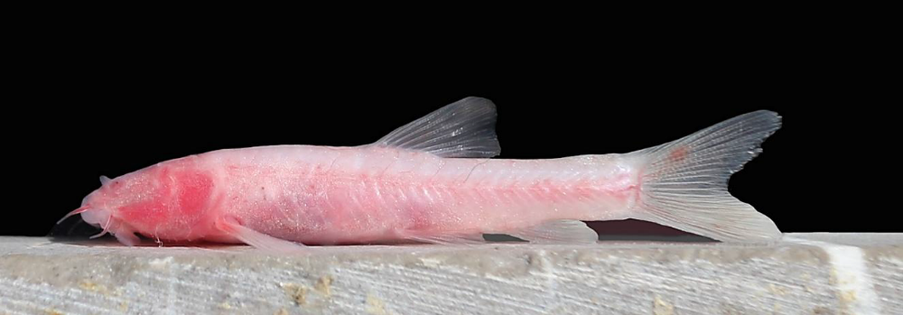
Figure 1. Garra tashanensis, paratype, 27 mm SL; Iran.
Table 1. Morphometric data .................

Characters*

*If you need explain more write here in this style
- Discussions
The history of subterranean cyprinids in Iran is recently reviewed and the current taxonomic status of them is well-discussed by Mousavi-Sabet and Eagderi (2016). The present study confirmed the second subterranean ecosystem for cave fishes in Iran, which contains the fourth subterranean species for the country. All the three known subterranean fishes from Iran are described from the same locality (Loven Cave), but the fourth species is described from a different locality.
Acknowledgements
We are pleased to thank R. L…, A. J… and F. S… for helping us with this study.

References

All references must be listed at the end of the manuscript under the heading "References." Ensure that every reference cited in the text is included in the References section, and that no uncited references are listed. Both in-text citations and the reference list must strictly follow the APA citation style. Several examples of the correct reference formatting are provided at the end of this template. Please pay close attention to the order of bibliographic information, the formatting, and the font size used in the reference list

Abdoli A. (2000). The inland water fishes of Iran. Naghsh Mana Publication. Tehran, 378 p. [in Persian]
Bianco P.G., Banarescu P. (1982). A contribution to the knowledge of the Cyprinidae of Iran (Pisces, Cyprinidae). Cybium, 6: 75-96.
Coad B.W. (2014). Freshwater fishes of Iran. Available from: www.briancoad.com. Retrieved 06 April.
Costa C., Cataudella S. (2007). Relationship between shape and trophic ecology of selected species of Sparids of the Caprolace coastal lagoon (Central Tyrrhenian Sea). Environmental Biology of Fishes, 78: 115-123.
Guill J.M., Hood C.S., Heins D.C. (2003). Body shape variation within and among three species of darters (Perciformes: Percidae). Ecology of Freshwater Fish, 12: 134-140.
Klingenberg C.P. (2011). MorphoJ: an integrated software package for geometric morphometrics. Molecular Ecology Resources, 11: 353-357.
Nacua S.S., Dorado E.L., Torres M.A.J., Demayo C.G. (2010). Body Shape Variation between Two Populations of the White Goby, Glossogobius giuris (Hamilton and Buchanan). Research Journal of Fisheries and Hydrobiology, 5: 44-51.
Patimar R., Nasri M. (2007). Investigation on age structure and growth of Lotak Cyprinion macrostomum Heckel, 1843, in Seimareh River, Ilam province. Journal of Agricultural Sciences and Natural Resources (Animal and Aquatic Sciences), 5: 12-22. [in Persian]
Webb P.W. (1982). Locomotor patterns in the evolution of actinopterygian fishes. American Zoologist, 22: 329-342.
Zelditch M.L., Swiderski D.L., Sheets H.D., Fink W.L. (2012). Geometric Morphometrics for Biologists: A Primer, 2. Elsevier Science and Technology. Amsterdam, Boston 504 p.

